Visegrad Four - Ukraine: energy security and prospects for market integration

A common challenge for the energy security of Ukraine and Visegrad is Russian project North Stream 2. It is still topical, although countries have made joint efforts with other states in Central and Eastern Europe for its blocking. The negative decision of the Polish Office of Competition and Consumer Protection, adopted in August, was a knockdown for the project, but it is not a knockout. We are witnesses of active attempts to split the solidarity of Central and Eastern Europe in this regard. In particular, we are talking about Gazprom’s attempts to neutralize opposition of the Slovak side. It is well known that Gazprom proposes Eustream to save transit through the Slovak GTS from Velke Kapusany to Lanzhot, offering to pump Russian gas from the second line of Turkish Stream through the route Eastring, developed by Slovak company.
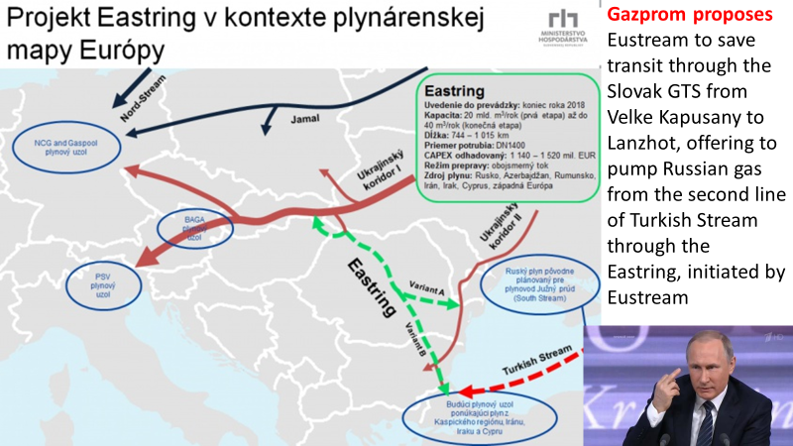

However, Germany, which until recently supported the project at all levels, is trying to develop more rigid position on Nord Stream 2 now. Norbert Röttgen, chairman of the foreign affairs committee in the Bundestag, urged the German government to stop the project. “The government should retreat from its position that North Stream 2 is just a business project, but not a political one. The project is wrong in terms of energy and foreign policy as it contradicts to all generally accepted principals that the EU supports in the all spheres” – Röttgen said asking Germany not to play a double game, but show solidarity with Poland, the Baltic States and Ukraine. We in Ukraine hope that despite certain corporate interest to Russian gas, the Slovak government will maintain its principled stance on blocking Nord Stream 2. Instead, it would be important to support the Polish project Northern Gate, which should bring Norwegian gas to Central Europe. Now this project gets a new window of opportunity. The Commission is looking to see if it can give the project “strategic assistance,” said Maroš Šefčovič, the ЕC vice president. Šefčovič said Central and Eastern Europe and the Baltic countries pay 16 to 24 percent more for gas compared to Western European countries — coming to an extra €1.3 billion a year. “This time we should not let this opportunity slip outside of our hands,” he said.
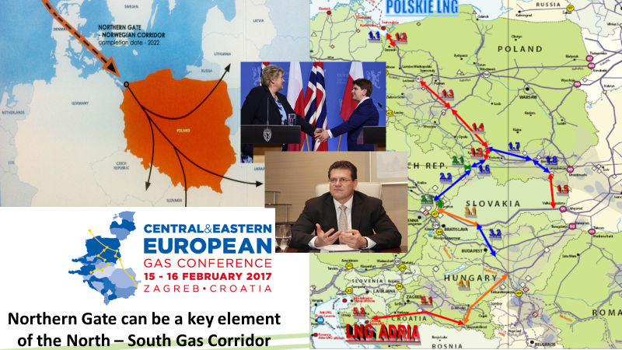

Northern Gate together with an LNG-terminal in Świnoujście could become the second key element of the North-South Gas Corridor, which until recently was so ardently maintained at V4 level where Slovakia with SGOA were its greatest lobbyists, and personally Mr. Ján Klepáč. Therefore, the support of the Polish project at the V4 level would be reasonable as it is in the interest of the Visegrad and the Energy Union, as well as in the interest of the Energy Community, the Baltic States and Ukraine. I think that Ukrainian government would also welcome the approach, which can be called ‘no to Russian gas weapon in the EU, no to German gas crane for the EU, yes to Norwegian gas commodity and the concurrence in Central and Eastern Europe’. Moreover, the Slovak presidency of the EU can contribute to the adoption of specific decisions in favor of the Northern Gate and the North-South Gas Corridor in terms of the allocation of the funds under the program PCI.

Incidentally, realization of the Northern Gate and the North-South Gas Corridor, given the capacities of Ukrainian GTS with its network of storage facilities in the western part of the country, may become the practical expression of the greater integration of gas markets in Central and Eastern Europe.
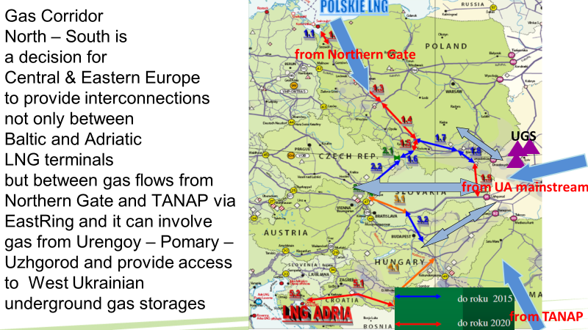

Whatever it was, Ukraine, albeit slowly, but still implementing the reform of the gas market in accordance with the EU Second and Third Energy Packages.

Although the Energy Community countries were left behind the EU Energy Union that I believe was a strategic mistake of the European bureaucracy, however, the prospect of limited integration model remains. It is important that the EU followed the provisions of the AA with Ukraine. Particularly, the Article 274 of AA clearly states: «With a view to further integrate markets of energy goods, each Party shall take into account the energy networks and capacities of the other Party when developing policy documents regarding demand and supply scenarios, interconnections, energy strategies and infrastructure development plans».

There is no need to rely on the Nord Stream 2 or the Turkish Stream, when proven for decades Ukrainian-Slovak route most suitable for the transportation of Russian gas to the EU exists. In this context, positive aspect is cooperation that appeared in the format of three operators - Ukrtransgaz - Eustream - Snam regarding the maintenance operation of the main transit route Urengoy-Pomary-Uzhgorod.

Finally very important is the cooperation of the V4 and Ukraine in the field of energy efficiency and transferring of practical skills from V4 to Ukraine. We are grateful to our partner Slovak RC SFPA Alexander Duleba and SlovakAid for supporting the relevant project, which helps Ukrainian side to develop practical actions for the implementation of the best practices in Ukrainian realities. Also, important is the advisory support to the energy sector reform, which represents Karel Hirman that already has considerable authority in Ukraine.

Of course, cooperation in the V4 + Ukraine format is not limited to gas sector. Simply, it is the most sensitive one. Important is the cooperation in the electricity sector, including nuclear energy, protection of critical energy infrastructure, including cyber protection, etc.

Ukraine has maintained the stability of its energy systems for two and a half years of Russian aggression, which is still ongoing and Russia seems not intend to finish it. In condition of the wars of hybrid type, the formations such as the EU are less viable than regional formats. We hope that the format V4 + (+ Ukraine, Moldova, Romania Bulgaria) can be a practical expression of the Intermarium idea that has serious energy basis. If to work seriously on this, not looking at Brussels and Berlin and without look round to Moscow.

