Mykhailo Gonchar,
President of the CGS ‘Strategy XXI’
Ukraine

About Ukrainian Gas&Transit, EU – Ukraine Energy Cooperation
And Energy Component of Russian Hybrid Warfare

Does Ukraine really have the lowest import price of gas in Europe?
According to the State Statistics Service of Ukraine, for the first eight months of 2015, Ukraine in total imported from Europe and the RF 11.686 bcm of natural gas with full value of $3.379 bln. Thus, the average price of imports was $ 289.1 per 1,000 cubic meters.
Imports from Europe amounted to 7.9345 bcm of gas at $2.245 bln. The price was $282.9 per 1,000 cubic meters.
From the Russian Federation, gas has been supplied in the total volume of 3.751 bcm at the total cost of $ 1.134 bln. The price was $302.3 per 1,000 cubic meters
Gazprom Export’s official said that Gazprom estimated an average price for gas deliveries to Europe in 2015 between $235 and $242 per 1,000 cubic meters.
Thus, Ukraine does not have the lowest prices of gas imports. If we take a retrospective, it is indicative of the fact that Gazprom exports gas to Ukraine at the highest possible price, using the position of a monopoly supplier.

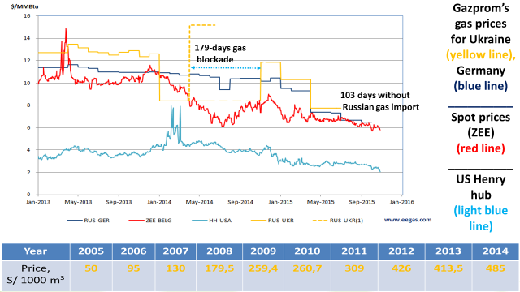

One of the claims of Naftogaz to Gazprom in the Stockholm arbitration relating to compensation for an overpayment due to non-market prices.

How much gas is transited through Ukraine, and what are the future prospects? What is the consumption of gas and the necessary gas storage capacity in Ukraine?
The situation with the transit, consumption and volumes of gas in the UGS is as follows. Note the table below:

Year  Items | 2005 | 2006 | 2007 | 2008 | 2009 | 2010 | 2011 | 2012 | 2013 | 2014 | 2015*
Transit to Europe (TtE), bcma | 121,5 | 113,8 | 112,1 | 116,9 | 92,8 | 95,4 | 101,1 | 81,2 | 83,7 | 59,4 | ~65,0
Consumption of Ukraine (CoU), bcma | 76,4 | 74,0 | 69,9 | 66,3 | 51,9 | 57,7 | 59,3 | 54,8 | 50,4 | 42,6 | ~36,5
Total (TtE+CoU), bcma | 197,9 | 187,8 | 182,0 | 183,2 | 144,7 | 153,1 | 160,4 | 136,0 | 134,1 | 102,0 | 101,5
Gas injected into UGS (PG), bcma | 15,3 | 18,1 | 18,0 | 15,9 | 11,0 | 13,4 | 10,9 | 13,7 | 11,6 | 9,8 | 8,34**  9,6***
PG/(TtE+CoU)  % | 7,73 | 9,64 | 9,90 | 8,68 | 7,60 | 8,75 | 6,80 | 10,1 | 8,65 | 9,60 | 8,22  9,46
* - projected on the results for 8 months; ** - as of October 15, 2015
*** - as of November 1, 2015

Here you see the retrospective volumes of transit and gas consumption in Ukraine. As can be seen, the volume of transit and consumption is now almost half as much as in 2008. Consequently, there is no need for Naftogaz to pump into the underground storage facilities the same amount of gas as it was before. If we look at the indicator of the injected gas ratio to the total annual volume of transit and consumption, we will see that there is no problem. An 8.22% indicator as of October 15, 2015 (a formal date of the heating season’s start in Ukraine) and a 9,46% indicator as of November 1, 2015 are at the average level of the recent years.

Therefore, it is not difficult to conclude that in 2015 the situation is not significantly different from 2011. Thus, the answer on the question how much gas is there in the Ukrainian underground gas storage is obvious – there is plenty of it in view of reducing the volume of transit and domestic consumption. JSC Ukrtransgaz works transparently and all its gas flows and volumes of gas in underground storage facilities are displayed from the middle of 2014 on the professional European resources GIE.

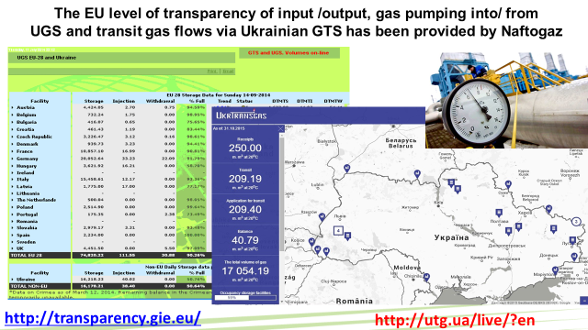

The propaganda campaign launched by Gazprom over a possible disruption of the transit to Europe by Ukraine, had three objectives:
- increase the volume of gas sales, inducing Ukraine and the EU to additional purchases of gas by Naftogaz through loans from European banks;
- continue discrediting Ukrainian route of transit of the Russian gas to Europe;
- prepare media environment for third gas crisis, accusing Naftogaz in disrupting the transit on the principle of "we warned yet in the summer that Ukraine would disrupt transit…»

A few comments on the future of transit, in the case when the project Nord Stream-2 will be implemented and if the GTS operator JSC Ukrtransgaz will be isolated from Naftogaz, in accordance with the unbundling procedure prescribed by gas sector reform in Ukraine. The level of transit at 40 billion cubic meters is critical in terms of the GTS functionality. GTS, created and developed under the condition of the annual volume of gas transportation at 240 bcm, cannot effectively function neither from the viewpoint of profitability nor in terms of technical functionality. I do not know what the government will do in such a situation, but my opinion is that Ukraine, Slovakia and Poland should jointly ask the EU to block Nord Stream - 2. Europe has a time - about six months - to block the initiative of Gazprom and five European companies that ignore the European energy legislation. However, I have doubts that the deflating EU and the helpless EC will do anything. Ukraine should not wait until 2020, when Gazprom and its partners with the support of the corrupt bureaucracy of some EU countries pay us damages.

Will the gas storage facilities in Ukraine be base for the Eastern Gas Hub, and will they be used to support the transit of Russian gas to Europe?
As for the UGS in Ukraine, they were originally created primarily to export Siberian gas to Europe. Therefore, now the Ukrainian underground storage facilities serve to support the stability of the transit. However, for this purpose it is necessary to Gazprom to pump extra gas in our underground storage facilities, but monopolist refuses to do it starting from 2010.

West Ukrainian UGS just may be the technological basis for the development of the Eastern European gas hub. Their convenient location close to the borders with the EU makes it possible to use them effectively for the business operations. Especially if the North - South project will be implemented and GTS of Poland and Ukraine will be joined by an additional interconnector.
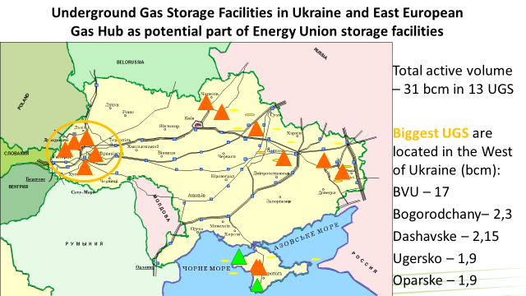

Given the current volume of transit and consumption of natural gas in Ukraine, about the half - 15 bcm of the total volume of 31 bcm is free. The European traders could use these capacities in future.

What are the risks of the Russian-Ukrainian crisis in the upcoming winter season compared to the previous year?
If you will call the things by their proper names, the basis of the Russian-Ukrainian crisis is the Russian aggression of hybrid type against Ukraine. The truce in the Donbass does not mean that aggression is stopped. Firstly, Russia has shifted the West’s attention on Syria. Secondly, the feature of the New generation war is the fact that every non-military mechanism to influence the enemy is used. Thirdly, the Russian hybrid aggression against Ukraine has an energy component. It is necessary to pay attention on it, if we want to get the answer on the question what awaits us in Ukraine and the EU in the upcoming winter. Although engaging energy influence tools on Ukraine, Russia during the hybrid war brought damage, but the damage was not of the fatal character for Ukraine. For example, last year Gazprom for 180 days, almost half a year, had not been supplying gas to Ukraine. This had not given the desired effect. Gas of its own production and reverse gas supply through Slovakia thanks to the Slovak Eustream mitigated the effects of Russian gas blockade. Besides, winter was warm and "General Frost" was not an ally of Russia. The Kremlin's strategic miscalculation was to underestimate an energy stability in Ukraine and the possibilities of the authorities to implement a set of measures to reduce energy consumption, to import coal from abroad, to maximize the use of nuclear power generation. In addition, it underestimated the degree of dependence of the annexed Crimea on supplies from mainland of Ukraine.

Donbass territories occupied by Russia are not economic and energy self-sufficient even taken into account the coal surplus. Gas supplies are provided from the Ukrainian gas transportation system, electricity - from the Integrated Power System of Ukraine. Therefore, there may be attempts to expand territories occupied by Russia to ensure greater energy and economic sustainability of the so-called DPR / LPR.

Thus, in winter of 2015-2016, a scenario of escalation is not excluded with the simultaneous application of the military component of the hybrid war and non-military methods of influence, primarily by stopping the supply of gas, coal and electricity to Ukraine. However, it is likely that there may not be military activity because Russia mired in Syria. In this case, Russia would use the non-military components of the hybrid war. Any type of energy supplies to Ukraine taken severally is not critical, but applied together at the winter temperature extremes they can lead to a cumulative effect, especially for the Integrated Power System of Ukraine.

Is there a real risk of interruption of gas transport through Ukraine and what are the possible implications for security of supply?
Speaking about Ukraine and its potential "share of the blame" for the probable disruption of gas transit to Europe then there are not, were not and could not be prerequisites. We have no interest in that happening. Gas transit brings revenues. At its peak in 2011, it was $3.24 bln per year. Now it is about $2 bln. Of course, this is not the main source of income for Naftogaz as a whole – it takes about 20-22% of total revenues. Moreover, these revenues exactly are not budget forming, as it often seems to Russian propaganda. Nevertheless, it is still a lot of money and jobs for thousands of people.

In order to predict the likelihood of gas transit interruption through Ukraine, it is necessary to pay attention to the acts of the Russian "gas aggression" against Ukraine in 2006 and 2009. In Europe, they are called "the Ukrainian-Russian gas crises" that reflects a traditional political desire of the European Commission to avoid calling things by their proper names. In fact, two large-scale use of the "gas tool" in foreign policy were disguised as the so-called Russian-Ukrainian gas crises in 2006 and 2009. The EU states also felt effects, as Russia had cut gas transit through Ukraine to Europe. The interruption of gas supplies to Ukraine and the reduction of transit through Ukraine to the EU in 2006 by the Russian Federation were "acts of reprisal". To Ukraine – for the Orange Revolution of 2004, to Europe - for their support of Ukraine.

Russia will continue to intimidate Europe by unreliability of Ukraine, although all previous Kremlin's "prophecies" about energy catastrophe in Ukraine without Russian gas, as well as disruption by Ukraine of gas transit to the EU, were only Putin’s propaganda theses. Scenario of gas supplies interruption to Ukraine and the EU remains in force for the period 2015-2016.

Moreover, the likelihood of this scenario has increased dramatically since September 4, 2015, when Gazprom and five European companies signed a shareholders' agreement about the project Nord Stream-2. This project contradicts to the fundamental principle of security of supply - the diversification of sources, routes and suppliers. According to our projection, Gazprom intended to provoke a large-scale gas crisis with gas transit interruption to the EU through Ukraine in order to incline the European Commission to support the Nord Stream-2 regarding «transit problems with Ukraine».

In condition of low prices for hydrocarbons, a competition between transportation routes will intensify. Rivalry between countries, lobbying certain routes will increase. Unconventional ways of rivalry will intensify. What does this mean in practice?

The Kremlin's dream in the field of gas transportation is as follows.

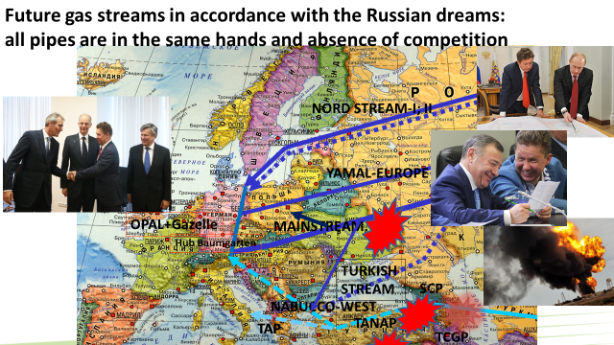

Given the lack of competitiveness of proposed by the Russian Federation routes, the aggressive behavior of Russia in international arena, hybrid aggression unleashed by the Kremlin against Ukraine, it is easy to come to a conclusion about how Russia will neutralize the competition and increase the attractiveness of projects lobbied by Gazprom. In addition to purely promotional Gazprom’s activity to discredit Ukraine as a transit link in the transportation of Russian gas to the EU, last year there have been acts of sabotage on the objects of Ukraine's GTS, which were to strengthen the propaganda rhetoric of a spectacular full-scale picture. Act of sabotage on the pipeline Urengoy - Pomary - Uzhgorod in fact was disguised as a technical incident, as it was in the place where, according to the in-line inspection of the pipeline, a big pipe wear took place and pipe should have been replaced. Importantly, however, extremely fast coverage of the event by Russian propaganda on Lifenews channel. Lifenews journalists constantly stood in a war zone in the Donbass, but "suddenly" "accidentally" in two hours after the incident, turned out to be in 500 km from the front line in the depth of the Ukrainian territory, in a remote area with poor roads, but just next to the place where the explosion took place and showed spectacular footage. It is clear that comments were appropriate and were built in a logical chain: Ukrainian gas transportation system in disrepair, An explosion - work of radicals from "Right Sector", Unstable Ukraine - a threat to the Russian transit to Europe, Russia and Europe need to build "South Stream". "South Stream" is not relevant, Nord Stream – 2 is, but the chain of logic is the same.

Now, pay attention to what is going on on the alternative routes of hydrocarbons transportation from the non-Russian sources. In particular, in Turkey during July-August there have been four attacks on the pipelines of the main oil and gas transportation routes. Militants of the PKK (Kurdistan Workers’ Party) renewed its armed struggle against the Turkish state and carried out attacks. Please note that blasts began in 5 weeks after the signing at the St. Petersburg Economic Forum a memorandum between Gazprom and a consortium of European companies on the implementation of the Nord Stream-2 project, and after tensions with Turkey on the Turkish Stream and on the Syrian issue. One can consider the events not interdependent, but we should remember that the PKK had been created by PGU KGB (The First Main Directorate (foreign intelligence) of the KGB of the USSR) and received comprehensive support from the Soviet Union and later Russia.

What is the status of gas reserves for the upcoming winter?
A few words about Ukraine's GTS. Its value is determined by not only the role of transit and large underground storage facilities with a total working gas volume of 31 bcm. An equally important is also a high level of interconnecting between main pipelines that provides an uninterrupted supply of gas in the event of an accident or other emergency. This is something that no other routes of transportation called by Gazprom as an alternative to the Ukrainian gas pipelines: Yamal - Europe, Blue Stream, Nord Stream, could provide. Failure in any of these areas will automatically lead to the cessation of gas supplies. Underwater pipelines generally are very difficult to repair.

Ukraine is another case. Examples. In 2007, there were two major technical incidents on the main gas pipeline Urengoy - Pomary - Uzhgorod. To eliminate the consequences of accidents, in both cases it took more than two weeks. However, the gas supply to the EU did not stop for a minute. Instead of the emergency pipeline, the parallel branches of two other pipelines - Progress and Soyuz, were involved. Similarly, it was in 2014, when in May and June sabotage operations have been on the main gas pipeline Urengoy - Pomary – Uzhgorod that did not result in an interruption of gas supplies to the EU for a second. It should be noted that for a complete interruption of gas supplies to the EU from Ukraine, it is necessary to make simultaneous blasts in 29 locations of the GTS facilities that is almost impossible task in a hybrid war. For comparison, in the case of the Slovak GTS, five blasts is enough. High level of GTS’ interconnecting is a guarantee of continuity of its operation, even in extreme conditions. No other GTS in Europe has such a level of interconnecting.

Now, it comes to the volume of gas in Ukrainian underground storage facilities and the traditional European concern about the winter risks for the transit of Russian gas through Ukraine to the EU. Traditionally, almost every year since the summer these problematics gets media stimulation through the mechanisms of Russian propaganda. Let me itemize more on this aspect.

To pass the winter season, a certain amount of gas in underground storage facilities is required. It can be used for both domestic supply and transit support. To meet winter peak domestic demand, Naftogaz of Ukraine makes commercial gas purchases with gas injection into underground storage facilities during the summer. Commercial gas purchases to support the transit are not provided in the existing contract with Gazprom. According to the contract, Naftogaz of Ukraine provides only the technical function of gas transporting. Gazprom and only Gazprom bears a legal responsibility to its European customers for deliveries. Naftogaz is not a third party in bilateral contracts of Gazprom with the European companies. In this context, Gazprom must place an additional amount of gas in underground storage facilities of Ukraine, specifically to support transit.

What are consequences of Russia’s plan to stop transit of natural gas via Ukraine for energy security of Central and South-Eastern European countries?
Russian plan "zero transit through Ukraine" is part of a broader Russia’s plan of “neogazpromization” of the European energy market. The essence of the plan is quite simple - creation of non-transit system of gas supplies from Russia to Europe with the simultaneous elimination of uncontrolled Russian transit routes through Ukraine and Slovakia, as well as the neutralization of competitive projects of gas supplies to Europe from non-Russian sources and routes that do not depend on Russia. Thus, it could be achieved by keeping the monopoly of Russian gas supplies to Europe from the east. This plan was developed under a scenario of rising oil prices, so now it gives some glitches, when oil prices fell more than two times.

Russian plan of “zero transit through Ukraine” would have such implications as the Ukrainian plan of “zero import of the Russian gas”. This plan is being accomplished gradually. It is a part of another plan of “zero gas import”. On the peak of gas prices, Ukraine spent on Russian gas import about $14 bln annually. The amount of revenues from transit of the Russian gas to the EU was at most $3.2 bln.

Is there a rationale and/or need in expanding the Energy Union so that it includes also Energy Community countries?
Energy Community was initiated and created by the EU. It is a mechanism of expansion and transformation of the energy space of the important countries neighboring to the EU itself. This transformation carries on, based on the implementation of the EU energy legislation to the national legislations of member countries of the Energy Community. This process is quite successful, but not without problems. It would be logical to grant membership in the Union to signatory states of the Energy Community Charter. This is the first option. The second option - to sign with each of the participating countries of Energy Community an association agreement with the Energy Union (similar to the existing AA). The third option - the signing (or update) of the relevant non-binding memorandum of cooperation in the energy sector.

Most likely, the EU will follow the third option - the easiest, formal and purely bureaucratic. In fact, it is marked in the core document of the Energy Union as of 25 February. This option will also satisfy the energy bureaucracy of a number of countries participating in the EC. In particular, the Ministry of Energy of Ukraine. The added value of the third option would be close to zero, but this, as it seems to me, is to what they strive in Brussels in order to not burden theirselves with unnecessary problems with the countries that are not EU members. Well this is an option, but it is necessary to understand its effects - the gradual erosion of power and degradation of the space around the EU. A fourth option also is possible. Against the background of the decay of common European policy spaces, the idea of an energy alliance would not be implemented. Therefore, any activity in this area loses its meaning. Against the background of the degradation of the EU, regional cooperation formats gain a greater sense.

What is the potential for regional cooperation in the field of security of gas supply?
Article 274 АА assumes the cooperation in the field of infrastructure use, particularly: «Parties should endeavor to promote the use of transmission and gas storage infrastructure and, if necessary, consult with each other or coordinate on the development of infrastructure. Parties should cooperate on issues of natural gas trade, sustainability and security of supplies.
In order to further the integration of energy products, each Party should take into account energy networks and the possibility of another Party while elaborating the programming documents on demand and plan of supply, interconnection, energy strategies as well as plans for infrastructure development”.
Therefore, it would be logical for Ukraine and Slovakia to initiate before the European Commission the issue of rejection of the Nord Stream - 2 as such a project, which is contrary to the basic principle of the EU's security of supply (diversification of sources, routes and suppliers). The project harms both countries and provides additional advantage of influence on the EU to the country that is not a member of the EU and practices weaponization of energy and infrastructure.
Visit of German Vice-chancellor Sigmar Gabriel to Moscow on 28-29 October, 2015 demonstrated that Germany at the governmental level openly supported project Nord Stream-2. By this, it actually has taken the path of ignoring the interests of other countries - EU members as well as associated partners.

At the end, the large-scale projects of non-transit gas export pipeline systems, initiated by Russia, could enhance the EU's dependence on Russian and German distribution hubs, if the project Nord Stream-2 would be implemented. It also increases the surplus of pipeline capacity under Gazprom’s control that will allow him to manipulate the directions and volumes of exports. In a situation of critical aggravation of relations between Russia and NATO and between Russia and one of the countries (group of countries) of the Alliance it can serve as a framework for the implementation of synchronized heterogeneous pressure by the threats projection to limit / interrupt deliveries combined with information-psychological campaign in the media and cyber-attacks.

To prevent in the future interruptions of energy supply and use of energy infrastructure as a means of keeping "energy wars", the system of confidence measures must be initiated. In order to minimize risks and not be nervous before every winter whether an interruption of gas supply will take place, it is necessary to establish a multilateral early warning mechanism, based on telemetric data.

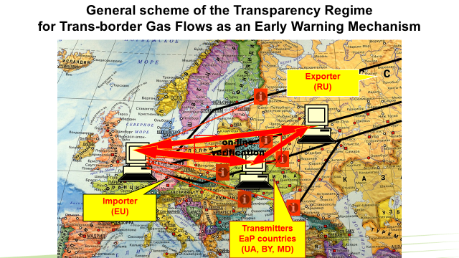

Вi-parametric on-line system of telemetric data monitoring (Working Pressure, Daily Gas Volume) could be installed, which would have to receive data from the appropriate gas metering stations (GMS) by mutual consent of the parties. Comparison of parameters provides an opportunity to identify bottlenecks over the entire way of gas flows moving from the border’s GMS to the consumer and clearly establish responsibility in case of gas traffic interruption. The initiative was presented in the EU on the meeting in the format (27+6) of the ministers of foreign affairs December 8, 2009 in Brussels, and also on the meeting of Working Group 3 «Environment, climate change and energy security» of Eastern Partnership May 20, 2010. The Cabinet of European Commissioner for Energy G. Öettinger also responded positively to this proposition. Nevertheless, unfortunately nothing happened. Despite the fact that this idea was supported at the level of the Secretariat of the Energy Charter Treaty in 2014, the EC considered it unnecessary. The explanation of this position quite primitive - there is a memorandum on an early warning mechanism between Russia and the EC, and it is enough. Unfortunately, this is not so. Until the mechanism of objective, instrumental control of transboundary movements of gas flows with no "human factor" appears, each coming winter will be nervous for Europe.

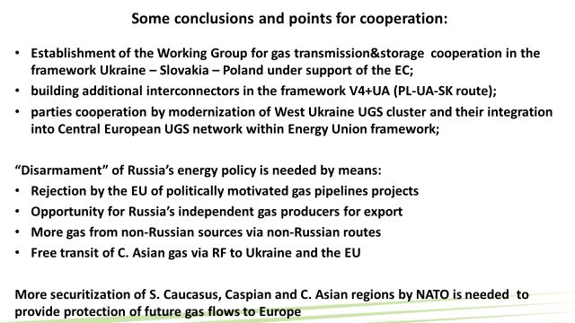

In difficult situations, it always worth asking a simple question “Que prodest?” and you will get an answer. I hope that my report also contributed to this. A description of how Russia applies an energy component of the hybrid war against Ukraine is available online on the website of the Center of Global Studies "Strategy XXI": http://geostrategy.org.ua/en/proekt/antares/item/893-energetichniy-komponent-viyni-novogo-pokolinnya-priklad-rosiyskoyi-agresiyi-proti-ukrayini/893-energetichniy-komponent-viyni-novogo-pokolinnya-priklad-rosiyskoyi-agresiyi-proti-ukrayini

